**LEBANESE AMERICAN UNIVERSITY**

**USAID – HIGHER EDUCATION SCHOLARSHIP PROGRAM**

**HES - Volunteering Program Verification Form**

This form is to be used to document volunteering hours. If a student volunteers for multiple organizations, a separate form must be used for each organization. **This form must be turned in by the 28th of each month, the latest.**

I certify that the scholar Bader Ahmad Damaj completed a total of 7 hours of service at Life Sculptor.

The hours were completed hours as per the below:

Hours # 0 (date) _30/09 – 5/10_ (initials of supervisor) __A.K.___

Hours # 0 (date) _7/10 – 11/10_ (initials of supervisor) __A.K.___

Hours # 2 date) _14/10 – 18/10 (initials of supervisor) __A.K.___

Hours # 5 date) _21/10 -25/10 (initials of supervisor) __A.K.___

Brief description of the activities the scholar performed or participated in:

I contributed to the writer's team by crafting an article on local news that highlighted the severe destruction in Lebanon and the ongoing hardships faced by its people. Additionally, I completed a USAID project (Bundle #43), conducting research on nine different topics and developing a PowerPoint presentation based on them. I also worked on a task where I compiled 12 tips to improve social media campaigns focusing on the connection between diet and mental health.

Written feedback about the scholar’s performance:

Bader has made valuable contributions through his writing and research efforts. His article on local news issues reflects his awareness of social challenges, while his work on the bundle project strong research and presentation skills. Additionally, his tips for enhancing social media campaigns highlight his analytical thinking and practical application of research findings.

Please rate the overall performance of the scholar at your organization:

|  |  |  |  |
| --- | --- | --- | --- |
|  | Mastery (5) | Proficient (3) | Emerging (1) |
| **Problem solver** | X |  |  |
| **Engaged & Committed** | X |  |  |
| **Open-minded & multicultural** | X |  |  |

Signature

& stamp

__________________________

_

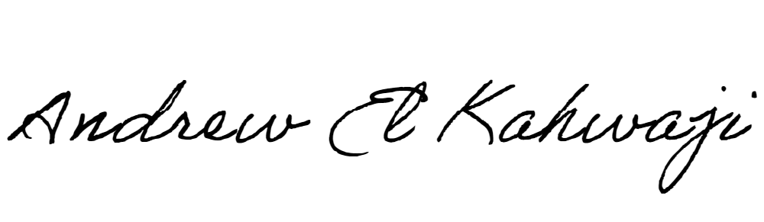

Printed Name _Andrew El Kahwaji_

Date __26/10/2024___

Email __andrew.lifesculptor.coo@gmail.com __

Phone __+961 71 914 378__

**LEBANESE AMERICAN UNIVERSITY**

**USAID – HIGHER EDUCATION SCHOLARSHIP PROGRAM**

